As we discussed last week, I've been trying to model protocols using FSP. In particular, we discussed using the property keyword to generate actions back to an error state. The effect I'm looking for is where multiple Java clients objects are using a single service object. The service object has a protocol, which can generate the allowed traces of the service. The clients have no knowledge of each other and can together quite easily violate the expected order of methods that the service expects.
Consider a very simplified attempt to model this, involving just one client (sharing can be used for multiple). If I model the client and the service as a property, I get the following FSP (note, tx = transmit, rx = receive):
deterministic Client =
(call.tx -> return.rx -> Client).
deterministic Service =
(call.rx -> return.tx -> Service).
property ||PClient = Client.
property ||PService = Service.
||Composition = (PClient || PService) / {call.rx / call.tx, return.tx / return.rx}.
Unfortunately, this generates the following LTS:

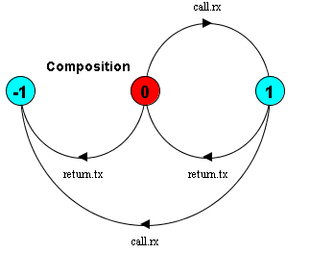
This is incorrect, due to the fact that the property PService LTS contains a set of return.tx actions to the error state. This will never happen in the Java program, as there is a relationship between a call and a return. In fact, the call.rx error transition cannot happen either.

What I really want is to treat transmit (tx) and receive (rx) actions asymmetrically. The LTS for a component should only care about the messages it receives that it cannot handle, not additional messages it shouldn’t send. This gives rise to the following FSP:

deterministic Client =
(call.tx -> return.rx -> Client).

deterministic Service =
(call.rx -> return.tx -> Service
|call.rx -> call.rx -> ERROR).

||Composition = (Client || Service) / {call.rx / call.tx, return.tx / return.rx}.

The last line of Service is where I have inserted my own error transition, based on the possibility of the receiving of an incorrectly sequenced message. This generates the expected LTS, showing that the client and server work just fine together:
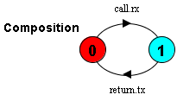
Also, this models the multiple client situation correctly. If I apply sharing, I get the following LTS, which models the Java situation correctly:

||Composition = (c1:Client || c2:Client || {c1,c2}::Service) /
{c1.call.rx / c1.call.tx, c1.return.tx / c1.return.rx,
c2.call.rx / c2.call.tx, c2.return.tx / c2.return.rx}.

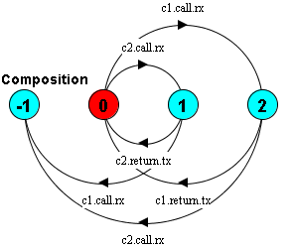
This correctly shows that if the service receives another call from a client at certain points, this will lead to error.

I guess what I’m basically after is a way of restricting the set of actions which lead back to the error state for the property keyword. i.e. property seems to add an error transition for all actions in the alphabet which don’t have a transition out of an existing state. I really want to limit this to a given set of actions so I can limit it to rx actions:

e.g. deterministic Service =
(call.rx -> return.tx -> Service).
Property PService = (Service) using only alphabet {call.rx} for error transitions rather than {call.rx, return.tx}.

Is this possible? Do you have an example in the book I should look at??

